Fit.ly Tech churn analysis presentation.
Project Overview and Business Goals.
- Churn has been creeping up in Fit.ly’s subscriber base over the past two quarters.
- Fit.ly needs to retain its customers because the cost of acquiring new users is rising.
- There is need to investigate churn drivers and some practical actions to take.
Business Goals:
- To clearly identify drivers of churn and practical actions to take heading into the next quarter in order to drive improvements and retain already existing customers.
- To identify patterns and KPIs that should be paid attention to by leadership.
Summary of my work.
What I Did:
To identify churn drivers and establish leadership KPIs, I conducted a comprehensive analysis across three data sources covering 400 customers, 918 support tickets, and 445 account activity events.
1. Data Validation and Cleaning
I performed systematic validation and cleaning on all three datasets to ensure data quality and enable accurate analysis:
Account Information (400 customers):
- Created binary churn indicator (1=churned, 0=active) from churn_status field
- Converted plan to categorical variable reflecting subscription tiers (Free, Basic, Pro, Enterprise)
- Created numeric user_id by removing "C" prefix from customer_id to enable dataset joins
- Verified data completeness: no missing values in plan_list_price; no duplicate customer_id or email records
Customer Support (918 tickets):
- Converted ticket_time to datetime format for temporal analysis
- Recoded missing channel values ("-") to "unknown" category
- Identified and flagged 43 GDPR deletion requests; retained in analysis as data is anonymized
- Validated data quality: no missing topic values; all resolution times positive; no duplicate user_id records
User Activity (445 events):
- Converted event_time to datetime format
- Verified data completeness: no missing values in user_id or event_type columns
2. Data Aggregation and Integration
I aggregated granular transaction data to customer-level metrics:
- Support metrics: ticket counts, average resolution times, topic breakdowns per customer
- Activity metrics: total events, engagement frequency, event type distribution per customer
Using LEFT JOIN operations, I merged all datasets on user_id, preserving all 400 customers to avoid selection bias. This approach retained customers with zero activity (154 customers, 39%) and no support contact (33 customers, 8%)—critical segments for identifying churn patterns.
3. Churn Analysis Across Three Dimensions
I analyzed churn rates and patterns across:
- Plan type: Identified Free plan's 41% churn rate vs. 22-26% for paid plans
- Engagement level: Discovered 54% churn for zero-activity customers vs. 13% for engaged customers (4 times difference)
- Support activity: Found 30% churn among support contacts vs. 15% for non-contacts; churned customers experienced 18.7-hour average resolution times vs. 6.7 hours for active customers
How This Addresses the Problem:
This systematic approach directly addresses the business problem in three ways:
- Identifies Root Causes: The analysis revealed that lack of product engagement is the primary churn driver (39% of customers have zero activity, churning at 54%), followed by support friction (billing issues show 36% churn correlation) and Free plan conversion failure (41% churn rate).
- Quantifies Business Impact: By retaining all customer records and calculating segment-specific metrics, I quantified that reducing zero-activity churn by 50% could save approximately 20 customers per quarter.
- Establishes Actionable KPIs: I defined 14 metrics with current baselines and targets across engagement (zero-activity rate: 39% → 25%), support (billing resolution: 12hrs → 6hrs), and conversion (Free churn: 41% → 30%), providing leadership with clear success criteria for the three priority interventions.
Analysis Focus: Identifying patterns, potential drivers of churn, and KPIs leadership should monitor based on engagement, support activity, and plan type.
Key Findings.
1. Zero Engagement is the Primary Churn Driver
39% of our customer base (154 customers) has never recorded a single activity event. Of these completely disengaged users, 53.9% have churned. In stark contrast, customers with any level of engagement show only a 12.6% churn rate. This represents a 4 times difference in retention.
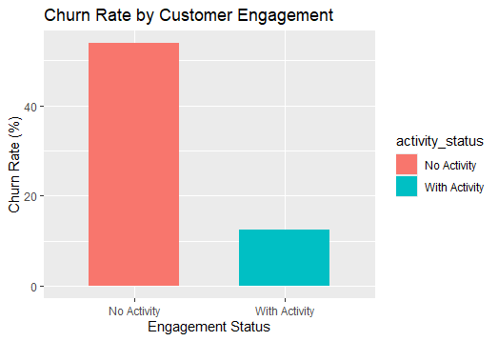
Among paid plan users specifically, disengaged customers on Basic, Pro, and Enterprise plans show churn rates of 58%, 43%, and 53% respectively. We are essentially losing every other paid customer who never engages with the product.

2. Support Contact Correlates With Higher Churn
Customers who contact support churn at 29.7%, compared to 15.2% for those who never file a ticket. More concerning, churned customers who did contact support experienced dramatically longer resolution times: an average of 18.7 hours versus 6.7 hours for retained customers.
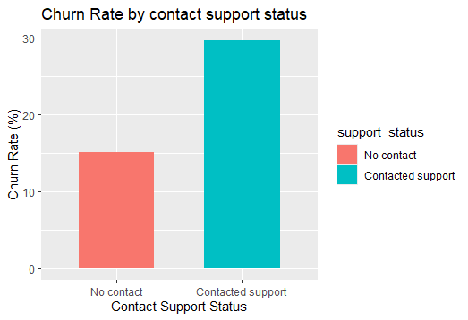
Billing-related tickets show the highest churn correlation at 36%, followed by unspecified channel contacts at 33%. While this doesn't prove causation, the pattern suggests customers reaching out for help are already experiencing friction that may lead to churn.
We also identified 43 GDPR data deletion requests in support comments, indicating customers actively seeking to remove their data from our systems.

3. Free Plan Users Are Churning Without Converting
Free plan users show the highest churn rate at 41%, despite representing 26.3% of our customer base (105 customers). Among disengaged Free users specifically, churn reaches 59%. This suggests we're failing to demonstrate value during the critical trial period, and users are abandoning the platform before experiencing what paid plans offer.
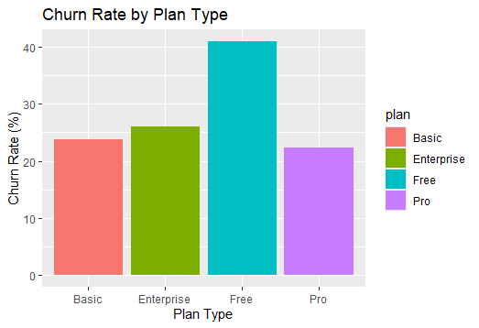
Recommended Metric to Monitor:
Zero-Activity Customer Rate (%) = (Customers with 0 Events / Total Customers) × 100
Current Estimation: 38.5% (154 customers)
Recommendations to the business.
Primary Recommendation: Launch an Activation Campaign for Zero-Activity Customers.
Immediate Actions:
- Create a 7-day onboarding sequence triggered at signup focusing on one core action per email (track a workout, watch a video, read an article)
- Identify customers at day 14 with zero activity and trigger an intervention campaign offering personalized setup assistance or a product walkthrough.
- For paid customers who have never logged an activity, ensure proactive outreach within their first 30 days.
Expected Impact:
If we move even 25% of these disengaged customers to minimal activity levels, we could prevent approximately 20 churns per quarter based on the 41-percentage-point difference in churn rates.
Success Metric: Increase percentage of new users logging their first activity within 14 days from current 62% to 75%
Other Recommendations:
- Reduce Support Resolution Times, Especially for Billing Issues - Faster resolution likely won't prevent all churn, but reducing friction for at-risk customers could retain 5-10% of those who contact support about billing issues.

Success Metric: Reduce average billing ticket resolution time from current levels to under 6 hours; track month-over-month churn rate for customers with billing tickets.

- Improve Free-to-Paid Conversion and Early Value Demonstration - Even if we can't convert all Free users to paid plans, demonstrating product value early should reduce Free churn to 25-30%

Success Metric: Increase Free-to-paid conversion by 5 percentage points; reduce Free plan churn to 30% or below.

